CUSTOMER SHOPPING BEHAVIOR ANALYSIS

1. Project overview-
This project focuses on analyzing consumer shopping behavior using a dataset of 3,900 retail transactions. The objective is to uncover key patterns in spending, customer demographics, product preferences, and subscription engagement so the company can strengthen its marketing, improve customer retention, and optimize sales strategies.
The analysis is carried out in three main phases:
- Python (Data Preparation):
Cleaned, formatted, and transformed the raw dataset into an analysis-ready structure.
- SQL (Data Analysis):
Performed exploratory and advanced queries to understand customer segments, loyalty trends, and purchase drivers.
- Power BI (Visualization):
Built interactive dashboards to showcase revenue patterns, customer groups, and product/category performance for decision-making.

2. Dataset Summary-
- Total Records: 3,900
- Total Columns: 18
- Key Data Fields:
- Customer Demographics: Age, Gender, Location, Subscription Status
- Purchase Information: Item Purchased, Category, Purchase Amount, Season, Size, Colour
- Behavioural Indicators: Discount Applied, Promo Code Used, Previous Purchases, Purchase Frequency, Review Rating, Shipping Type
- Missing Values: 37 missing entries in the Review Rating field

3. Exploratory Data Analysis(EDA) using Python-
We began with data preparation and cleaning in Python:

● Data Loading: Imported the dataset using pandas
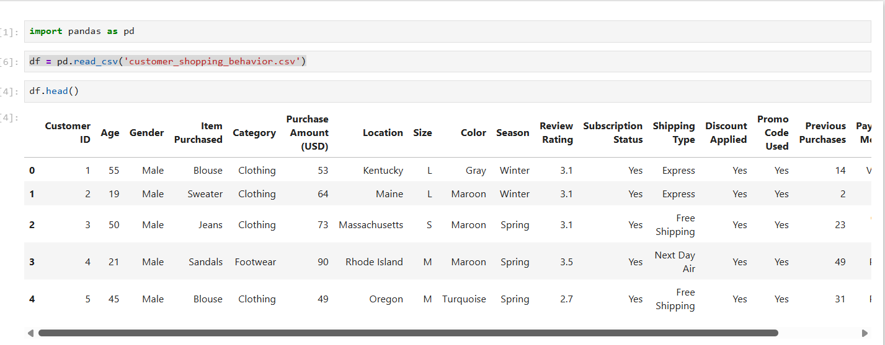

● Initial Exploration: Used df.info () to check structure and. describe () for summary statistics.
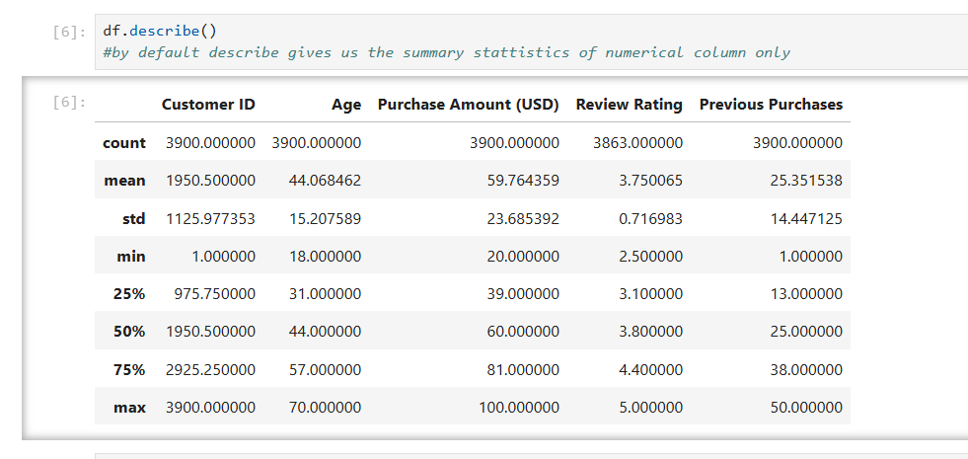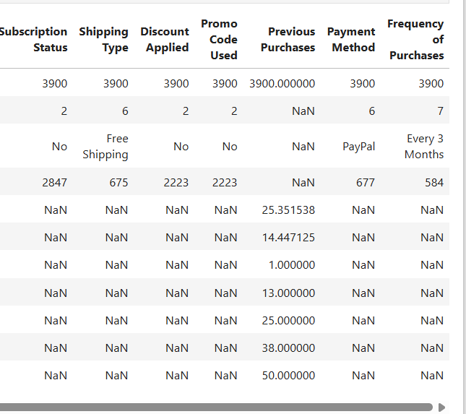
● Missing Data Handling: Checked for null values and imputed missing values in the Review Rating column using the median rating of each product category.

● Column Standardization: Renamed columns to snake case for better readability and documentation.

● Feature Engineering:
- Created age_group column by binning customer ages.
- Created purchase_frequency_days column from purchase data

● Data Consistency Check: Verified if discount_applied and promo_code_used were redundant; dropped promo_code_used.

● Database Integration: Connected Python script to PostgreSQL and loaded the cleaned DataFrame into the database for SQL analysis

4. Data Analysis using SQL (Business Transactions)-
We performed structured analysis in PostgreSQL to answer key business questions:

1. Revenue by Gender – Compared total revenue generated by male vs. female customers.

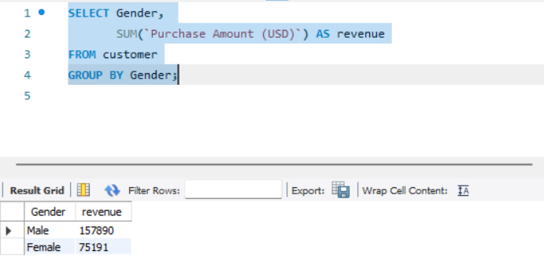

2. High-Spending Discount Users – Identified customers who used discounts but still spent above the average purchase amount.

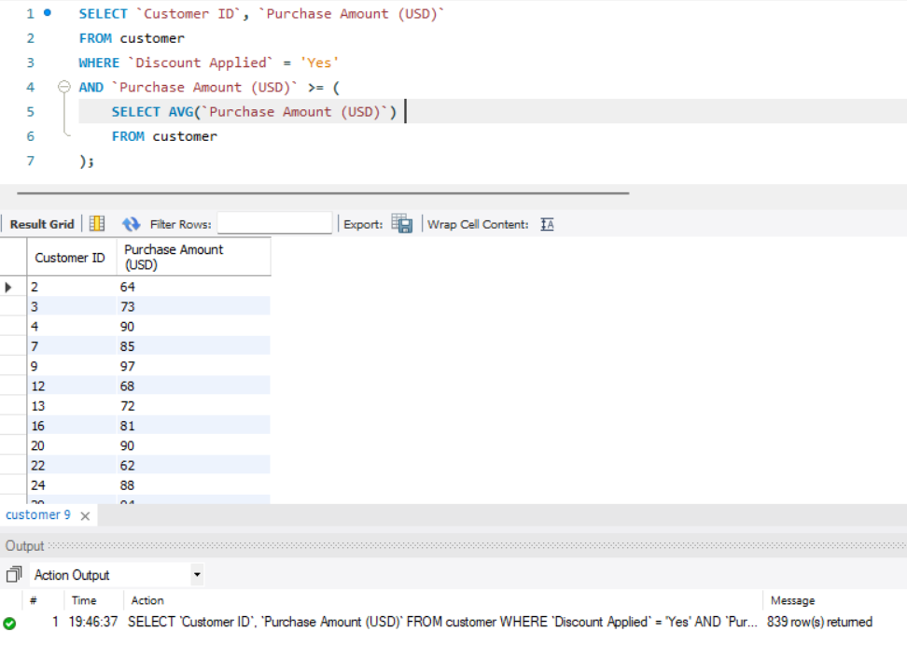

3. Top 5 Products by Rating – Found products with the highest average review ratings.
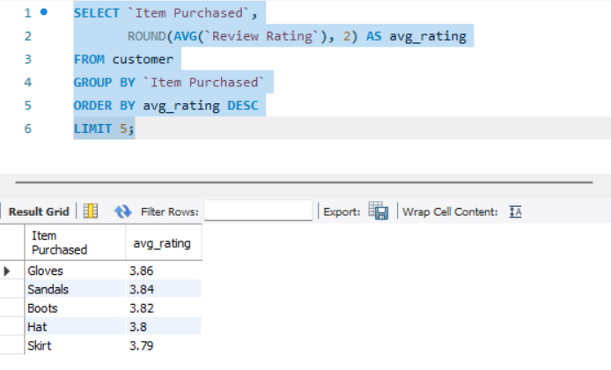
4. Shipping Type Comparison – Compared average purchase amounts between Standard and Express shipping.

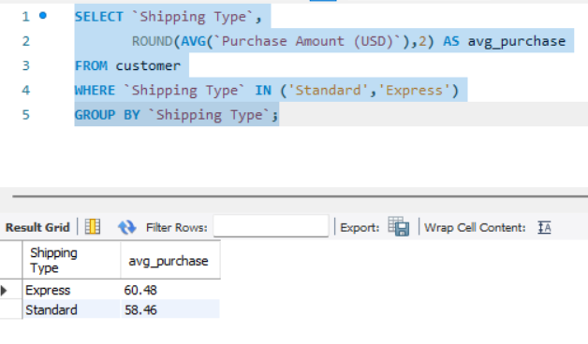

5. Subscribers vs. Non-Subscribers – Compared average spend and total revenue across subscription status.

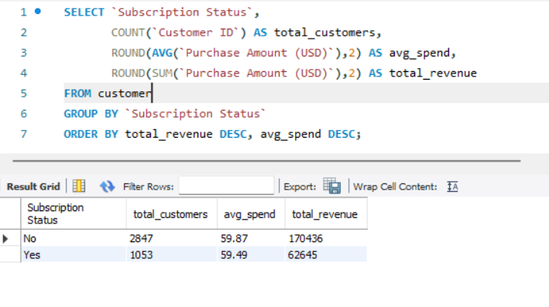
6. Discount-Dependent Products – Identified 5 products with the highest percentage of discounted purchases.

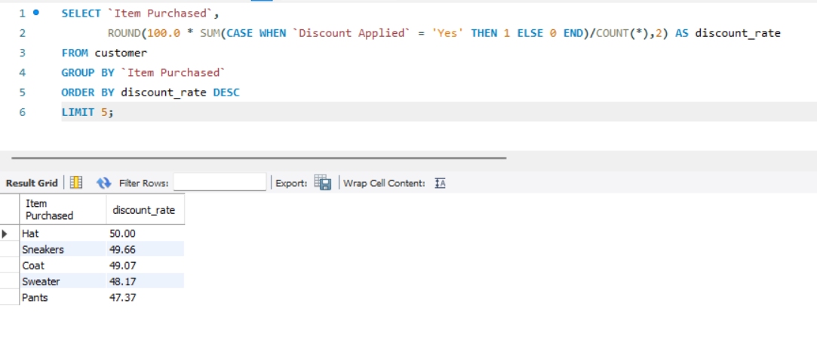

7. Customer Segmentation – Classified customers into New, Returning, and Loyal segments based on purchase history.

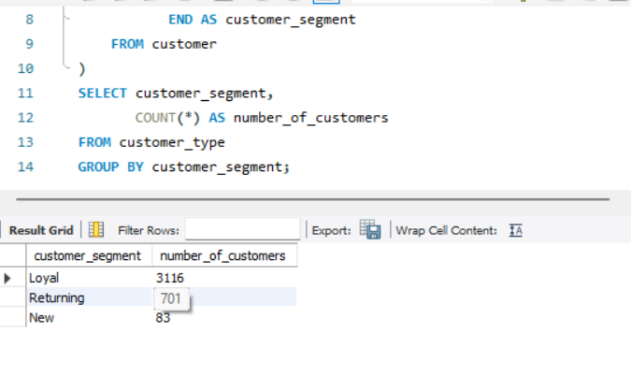

8. Top 3 Products per Category – Listed the most purchased products within each category.
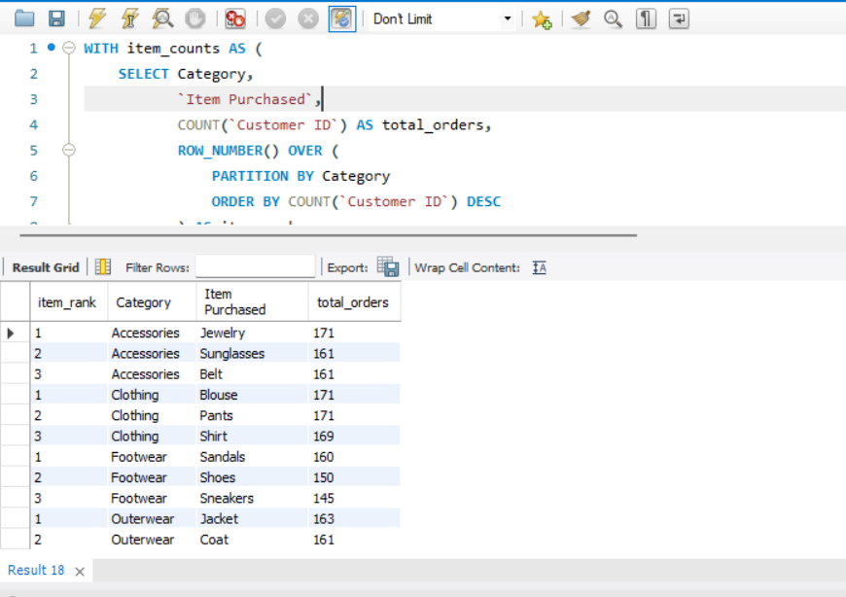

9. Repeat Buyers & Subscriptions – Checked whether customers with >5 purchases are more likely to subscribe
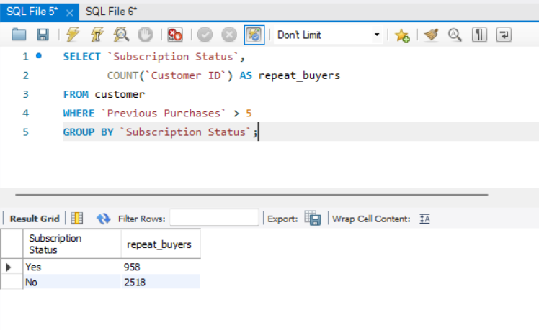
10. Revenue by Age Group – Calculated total revenue contribution of each age group.
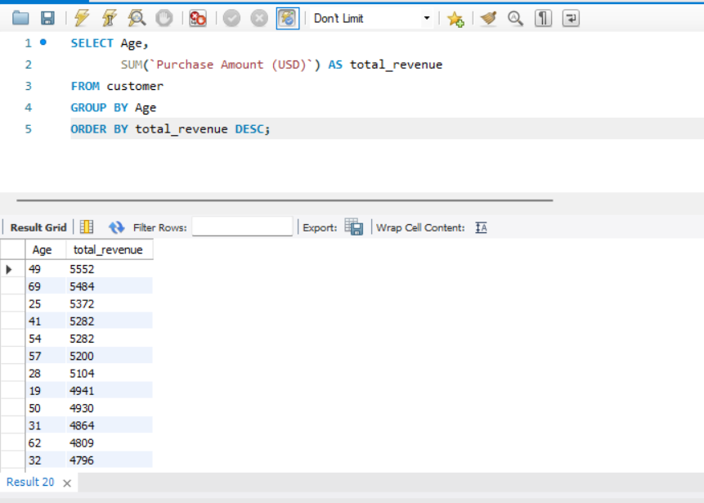

5. Dashboard in Power BI-
Finally, we built an interactive dashboard in Power BI to present insights visually.

- The dashboard gives a clear visual overview of customer behavior across spending, subscription status, age groups, and product categories.

- Key KPIs (Total Customers, Average Purchase Amount, Average Review Rating) help quickly understand overall business performance.

- The subscription donut chart shows a high proportion of non-subscribers, indicating potential for targeted marketing.

- Age-group revenue and sales charts help compare buying power across customer segments.

- Slicers for Subscription Status, Gender, Category, and Shipping Type enable easy filtering and deeper drill-down analysis without manual effort.

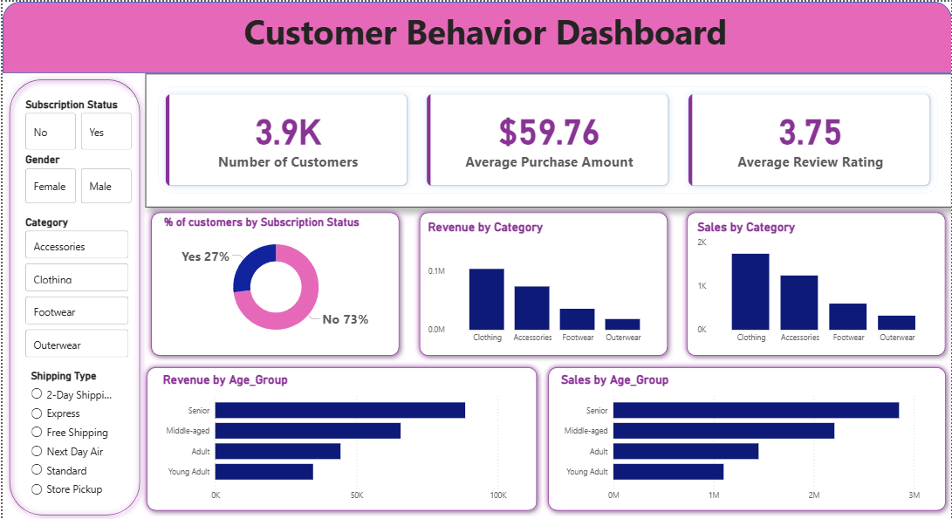
6. Business Recommendations-
● Boost Subscriptions – Promote exclusive benefits for subscribers
● Customer Loyalty Programs – Reward repeat buyers to move them into the “Loyal” segment.
● Review Discount Policy – Balance sales boosts with margin control.
● Product Positioning – Highlight top-rated and best-selling products in campaigns
● Targeted Marketing – Focus efforts on high-revenue age groups and express-shipping users.
● Optimize Inventory Planning – Stock more of the high-demand categories (Clothing, Accessories) and reduce low-movement items to cut storage costs.
● Improve Review Engagement – Encourage more review submissions to strengthen product credibility and boost organic sales.
●Improve Performance of Low-Selling Categories – Footwear and Outerwear have lower sales; consider discounts, bundling, or better product positioning.
● Focus on High-Revenue Categories – Clothing and Accessories consistently lead in both sales count and total revenue, so marketing and stock planning should prioritize these categories.

